How to upload and share videos with your students?

1. Enter the course you where you would like to add your media.
2. In a content area, hover your mouse over **Tools**and select ***Kaltura Media.***

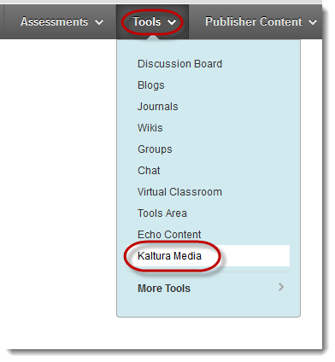

1. Provide a name for the video (e.g. Chapter one video).

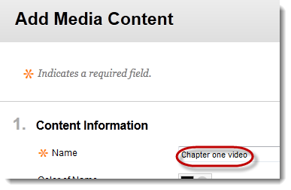

1. Click on **Add Media** to upload your video.

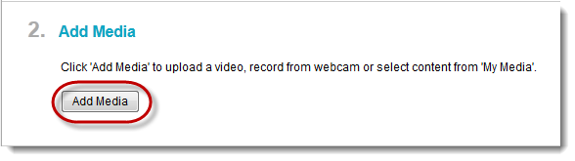

1. Under the upload tab, click on ***Browse***.

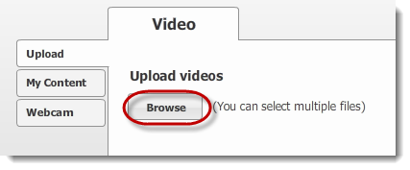

1. Select the media you would like to add and then click ***Upload***.

**Note:** This may take a moment depending on the file size and your internet speed.

1. Once the video has uploaded, click ***Next***.
2. For your video’s title, leave it the same and click ***Next***.
3. Your uploaded video will appear in the text editor.

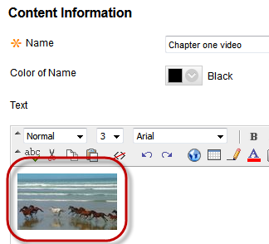

1. Once you have chosen your options for this video, click **Submit.**